

LAISmart V1.9 User Manual

Updated March 2021

**contents**

1. Introduction 1

2. Installation 1

3. Basic Functionalities 2

3.1. Login/Sign up 2

3.2. Home 3

3.3. Find 4

3.4. Data 5

3.5. Me 6

3.6. Setting 10

4. Using LAISmart Step By Step 14

4.1. Setting parameters 14

4.2. Measuring LAI 15

4.3. Viewing data 16

# Introduction

LAISmart is a free application developed by Qu Yonghua (qyh@bnu.edu.cn) from State Key Laboratory of Remote Sensing Science, Beijing Normal University. The application is a portable measuring device based on photographic imaging technology, which can quickly obtain the vegetation canopy structure parameter -- leaf area index (LAI). The application makes full use of the imaging and high-performance computing functions of the current mature intelligent terminal devices, and has the function of real-time calculation of LAI. Meanwhile, it provides users with operation and data processing options, which is convenient for users to make measurement settings according to actual conditions. Compared with existing smart phone LAI measurement systems, LAISmart has the following 3 advantages:

(1) Flexible options on the shoot angle, not limited to a single 57.5° shooting angle;

(2) Flexible options on the algorithm of image processing, users can choose the appropriate classification features according to actual conditions;

(3) An integrated field measurement equipment can greatly improve the work efficiency of users in the field.

# Installation

LAISmart should run on Android operating system. The APK file can be downloaded to your smartphone or tablet from: <https://github.com/niugankeji/diyaobao>

You should run the APK file manually after the download. When you run LAISmart first time, the software startup page will pop up, as shown in Figure 1.



*Figure 1 LAISmart startup interface*

# Basic Functionalities

## Login/Sign up

When you run LAISmart, the first step is to sign up or login, as shown in Figure 2.

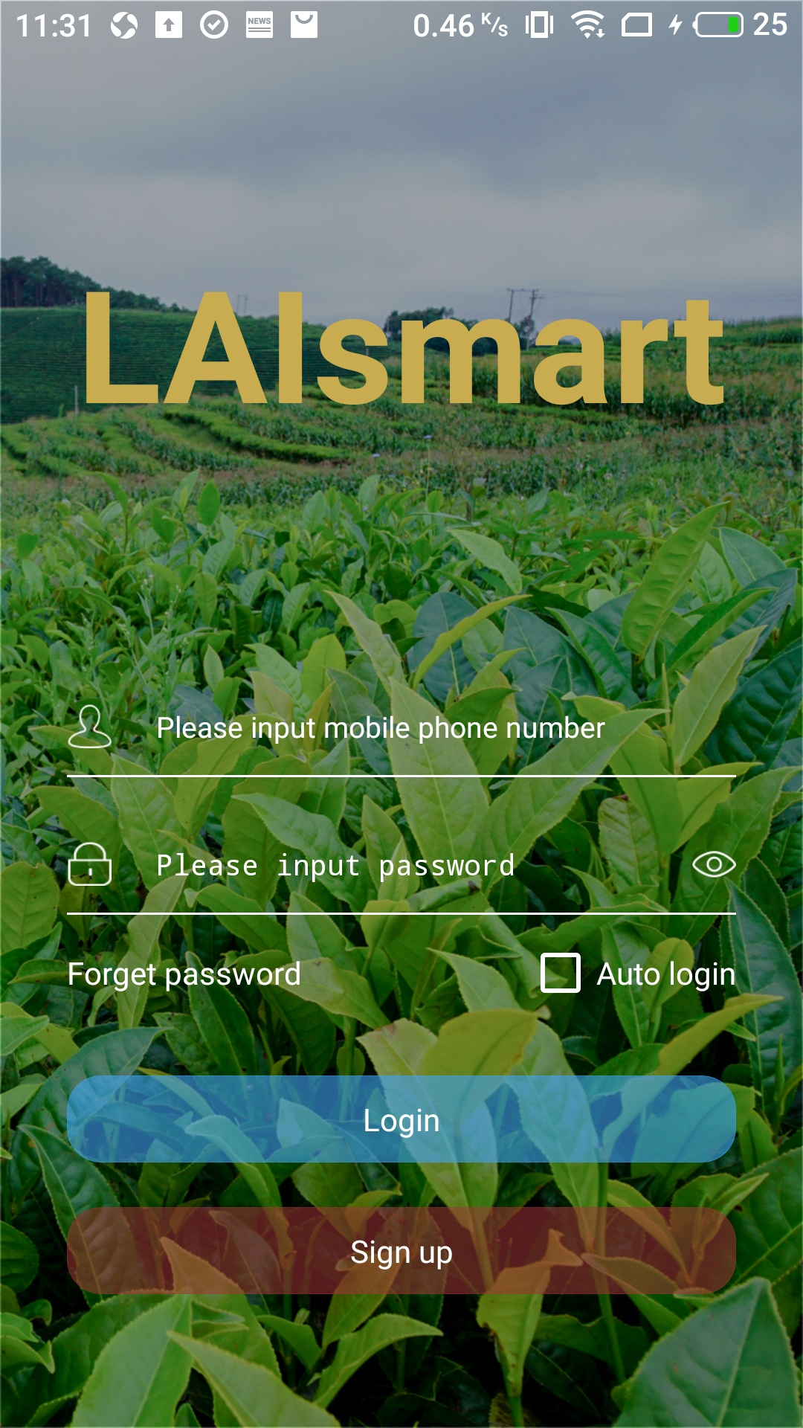

*Figure 2 Login/Sign up interface*

* Login: Input "mobile phone number" and "a password", and then click "Login" to complete the login of application software. You can check the checkbox for "Auto login"，then you can directly enter the home interface next time you open the software. If you forget your password, you can click "Forget password" to reset the password.
* Sign up: If you need to sign up an account, click "Sign up" to open the “Regist” interface, as shown in Figure 3. Fill in "mobile number" and click "Send verification code", then you will get your verification code. Please “enter the verification code” and “set the password”. In the process of register, you can view and check the checkbox for "I have read the privacy agreement carefully". When all the above informations are completed then click “Finish”.

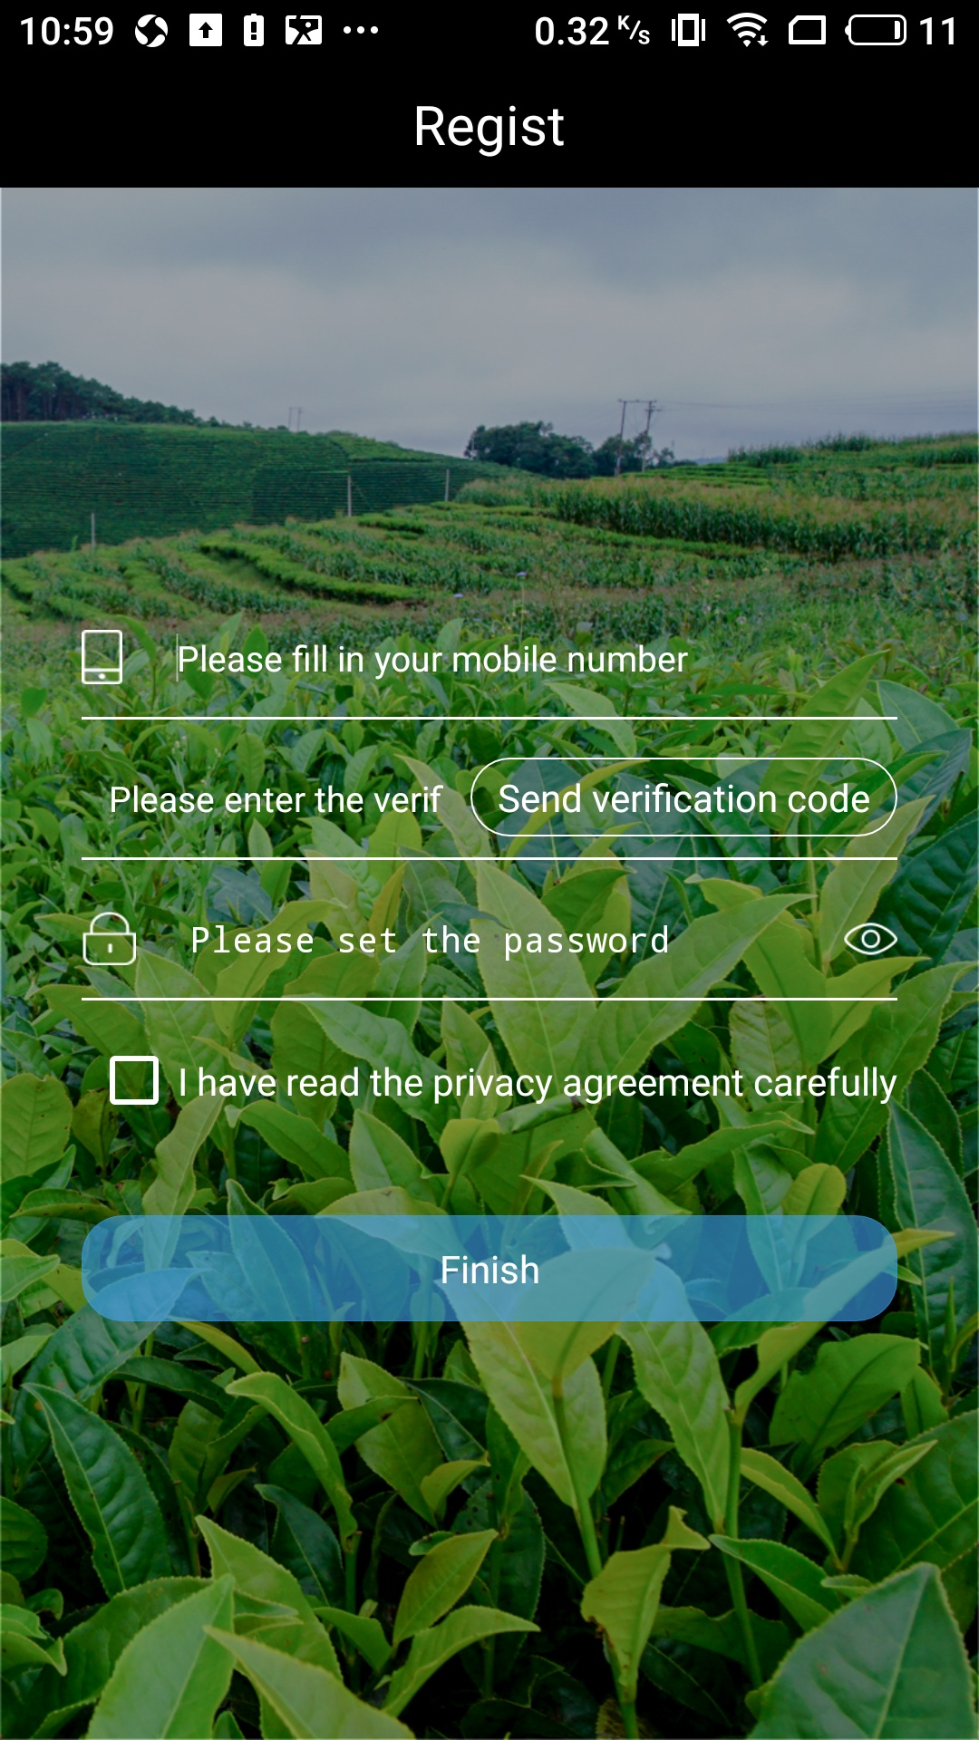

*Figure 3 Regist interface*

## Home

After logging in, users can directly enter the "Home" interface as shown in Figure 4.

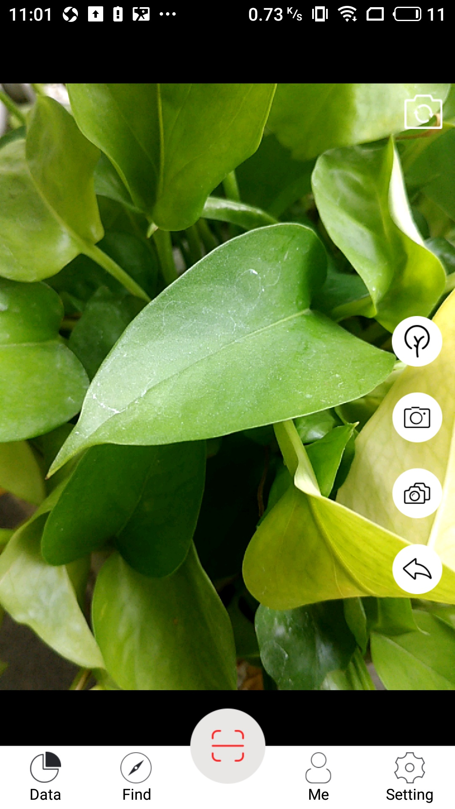

*Figure 4 Home interface*

The functions of the home interface are as follows:：

* ：Click the button to open the scan plant type recognition function.
* ：Click the button to open the single measurement of LAI function.
* ：Click the button to open the continuous multiple measurement of LAI function.
* ：Click the button to return to the home interface.

## Find

Click "Find" to enter the find interface as shown in Figure 5. You can view nearby users and nearby data through the map, or click "Search" in the upper right corner to search for friends through the user's nickname or ID, and check the data of friends.

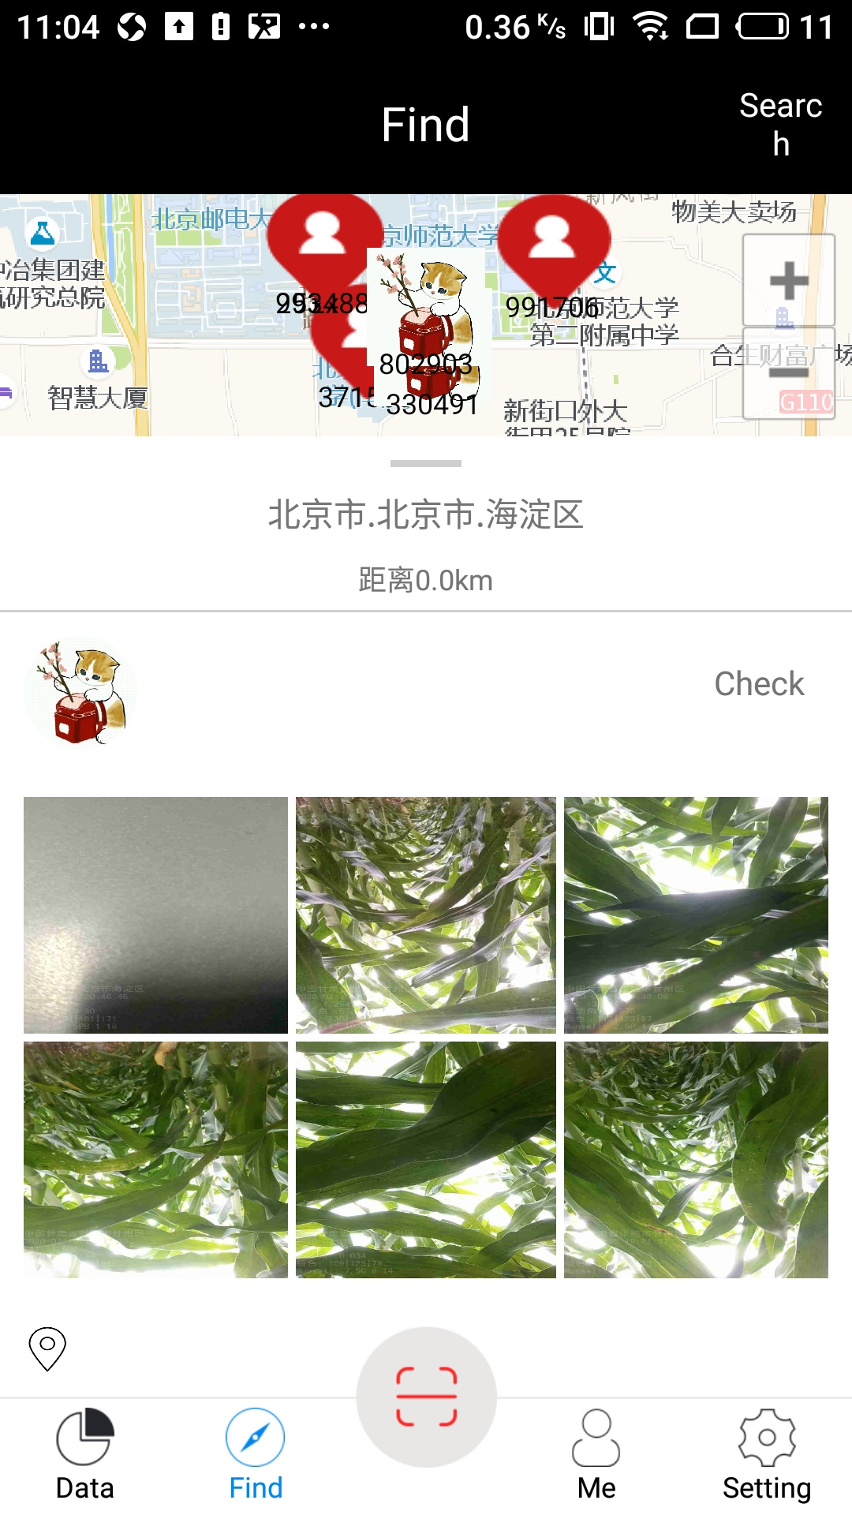

*Figure 5 Find interface*

## Data

Click “Data” to enter the data interface as shown in Figure 6.

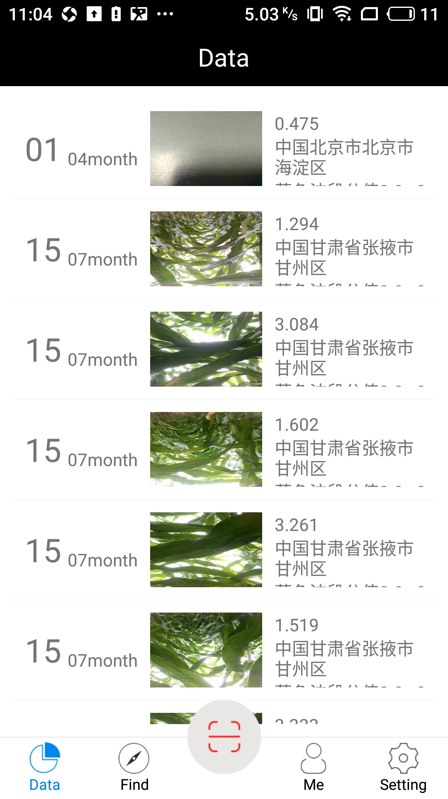

*Figure 6 Data interface*

* Data details: Click the picture to view the “Data details”. The interface as shown in Figure 7.

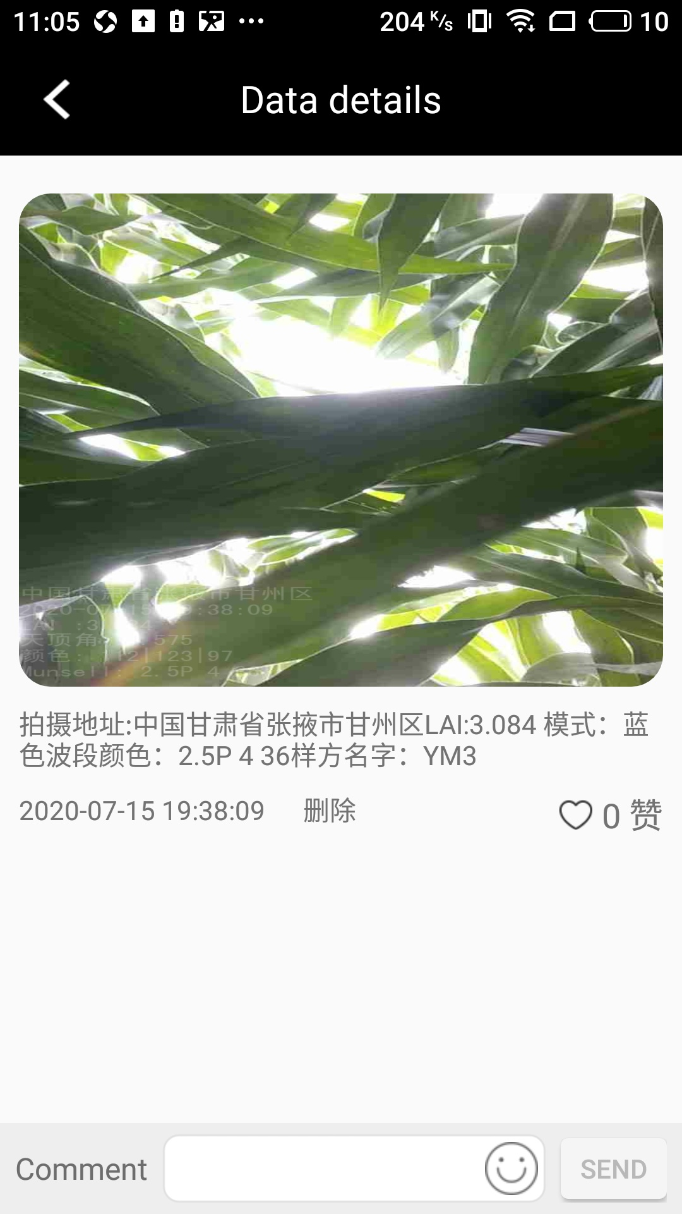

*Figure 7 Data details interface*

## Me

Click "Me" to enter the me interface as shown in Figure 8. "Me" interface includes “Personal information”, “Accounts and security”, “Who applied to view my data”, “My application”, “My wallet”, “Move” and “exit” functions.

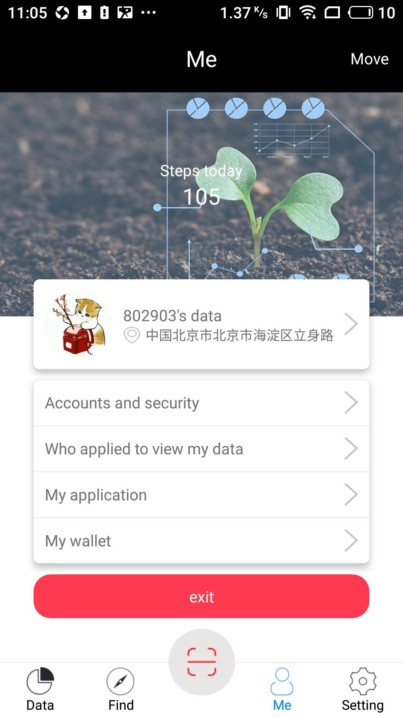

*Figure 8 Me interface*

* Personal information

As shown in Figure 9, users can modify the profile photo, “Nickname”, “Gender”, “Birth”, “Email” and “Personal signature”.

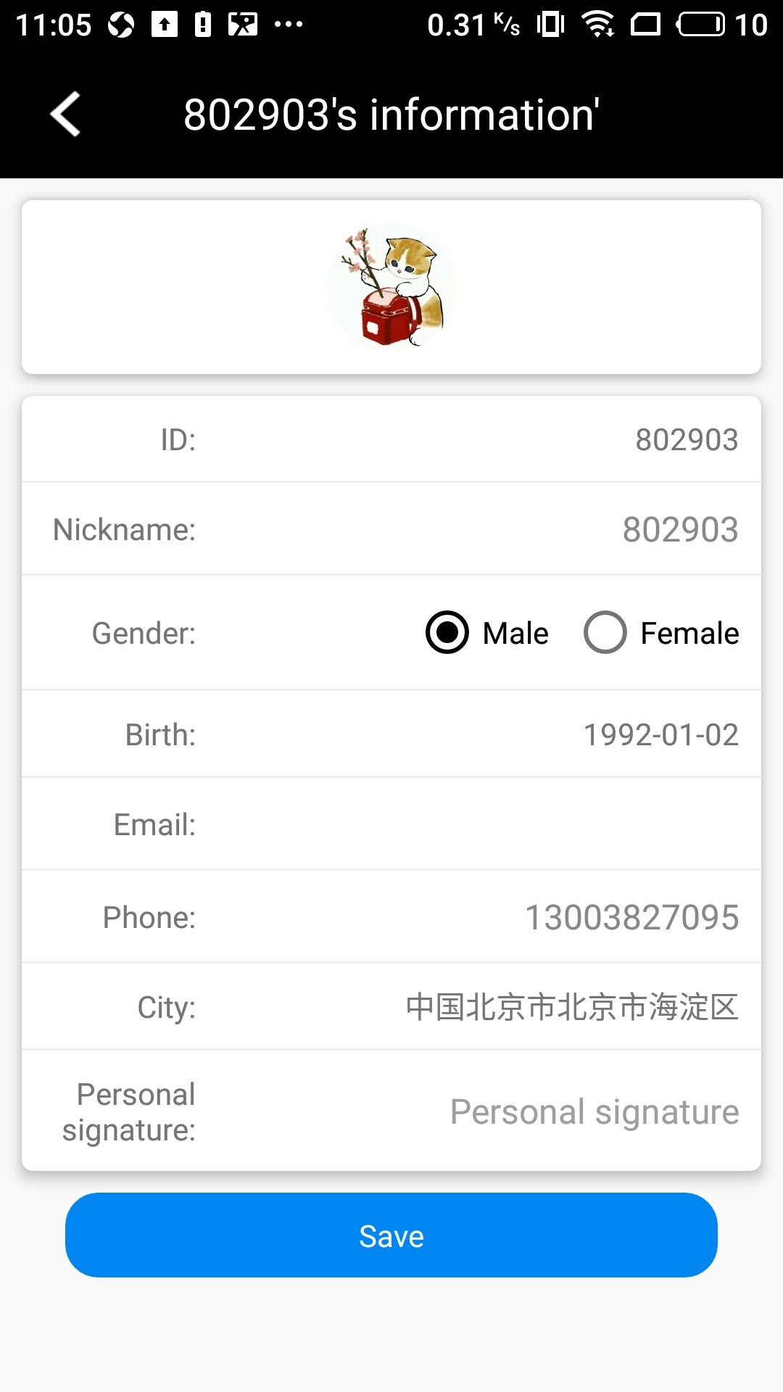

*Figure 9 Personal Information interface*

* Accounts and security

As shown in figure 10, users can modify “mobile phone number” and “password”.

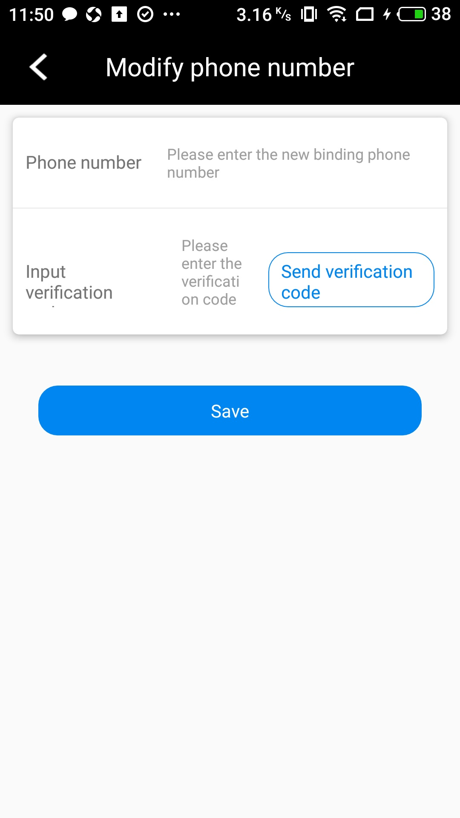 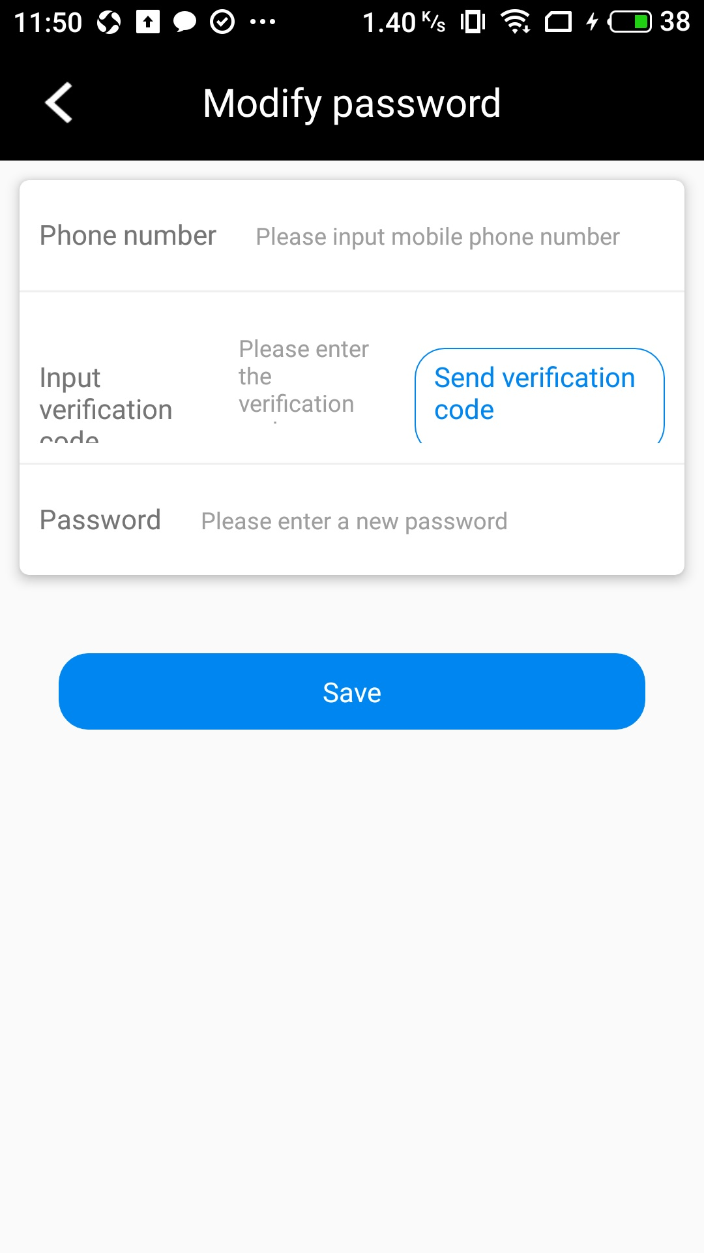

*Figure 10 Accounts and security interface*

* Who applied to view my data

When a friend applies to view your data, the interface as shown in Figure 11. Who applied to view my data has two states: one is “Pending”; the other is “agree”.

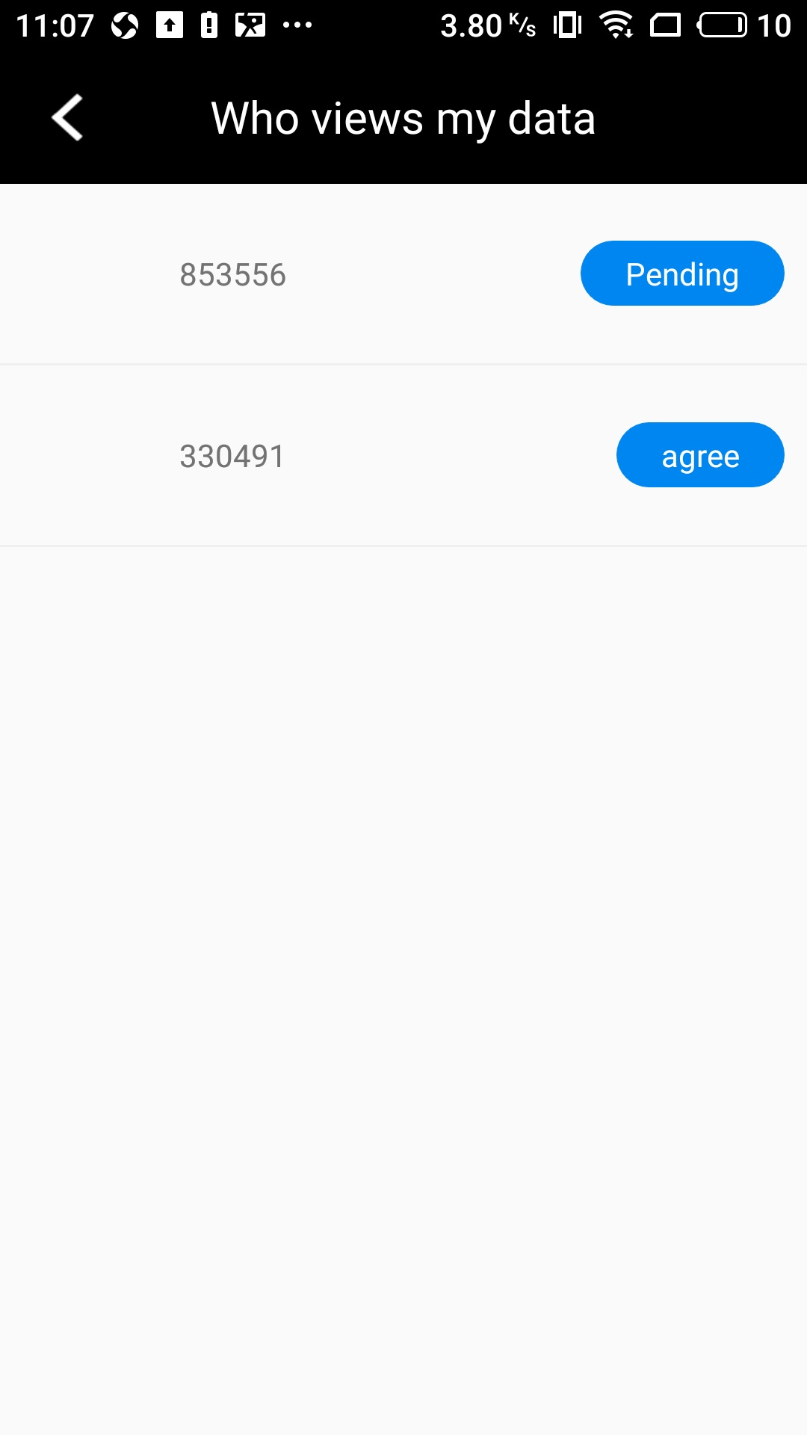

*Figure 11 Who applied to view my data interface*

* My application

My application also has two states: one is “Pending”; the other is “agree”. The interface as shown in Figure 12.

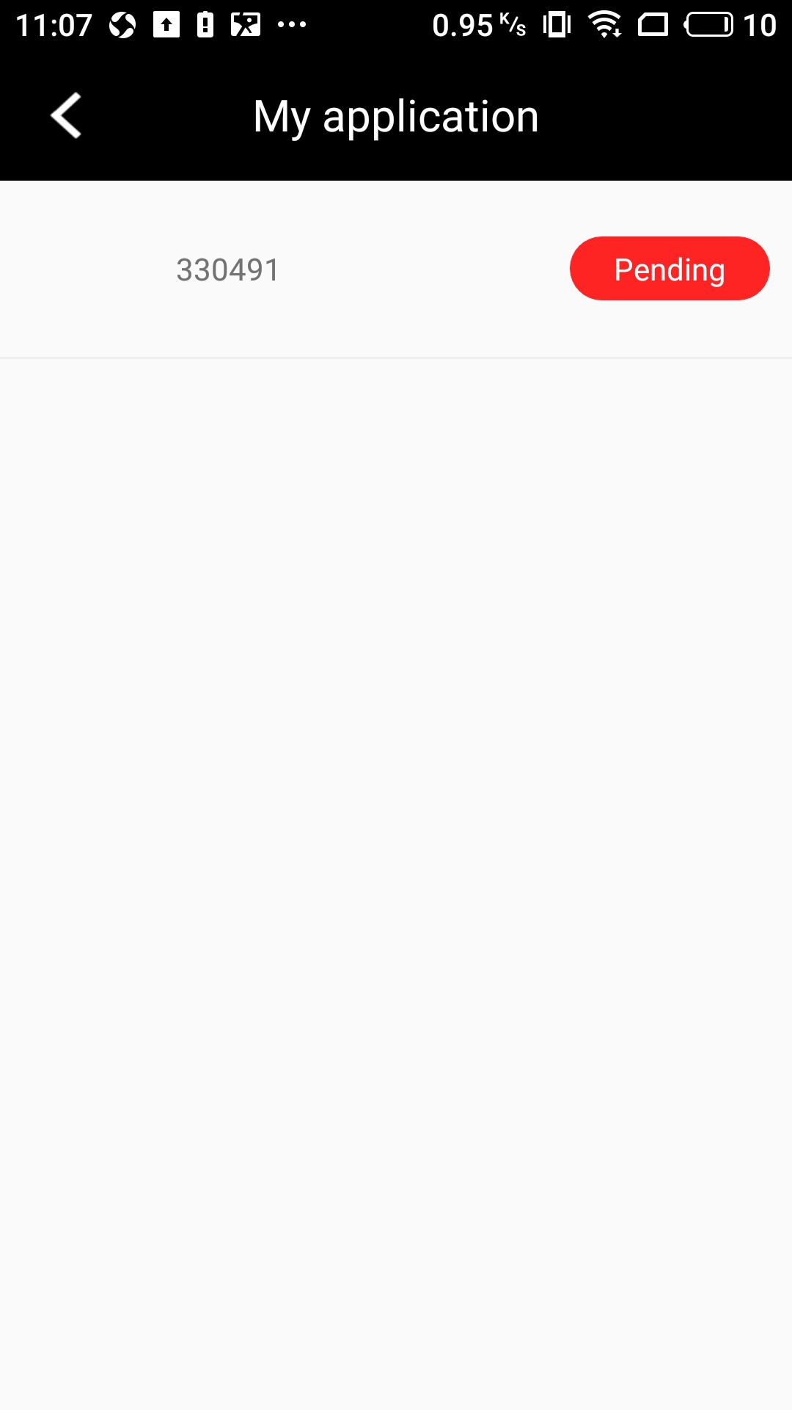

*Figure 12 My application interface*

* My wallet

As shown in figure 13, users can view “My reward point”, “Access to records” and “Get rules”.

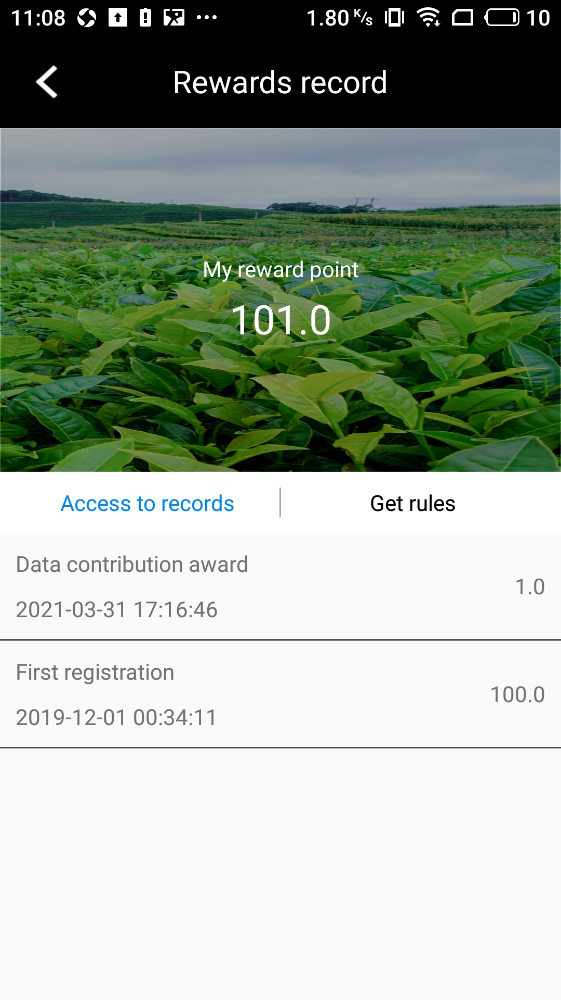

*Figure 13 My wallet interface*

* Move

Click "Move" in the upper right corner, and the interface will jump to the interface of exercise map as shown in figure 14.

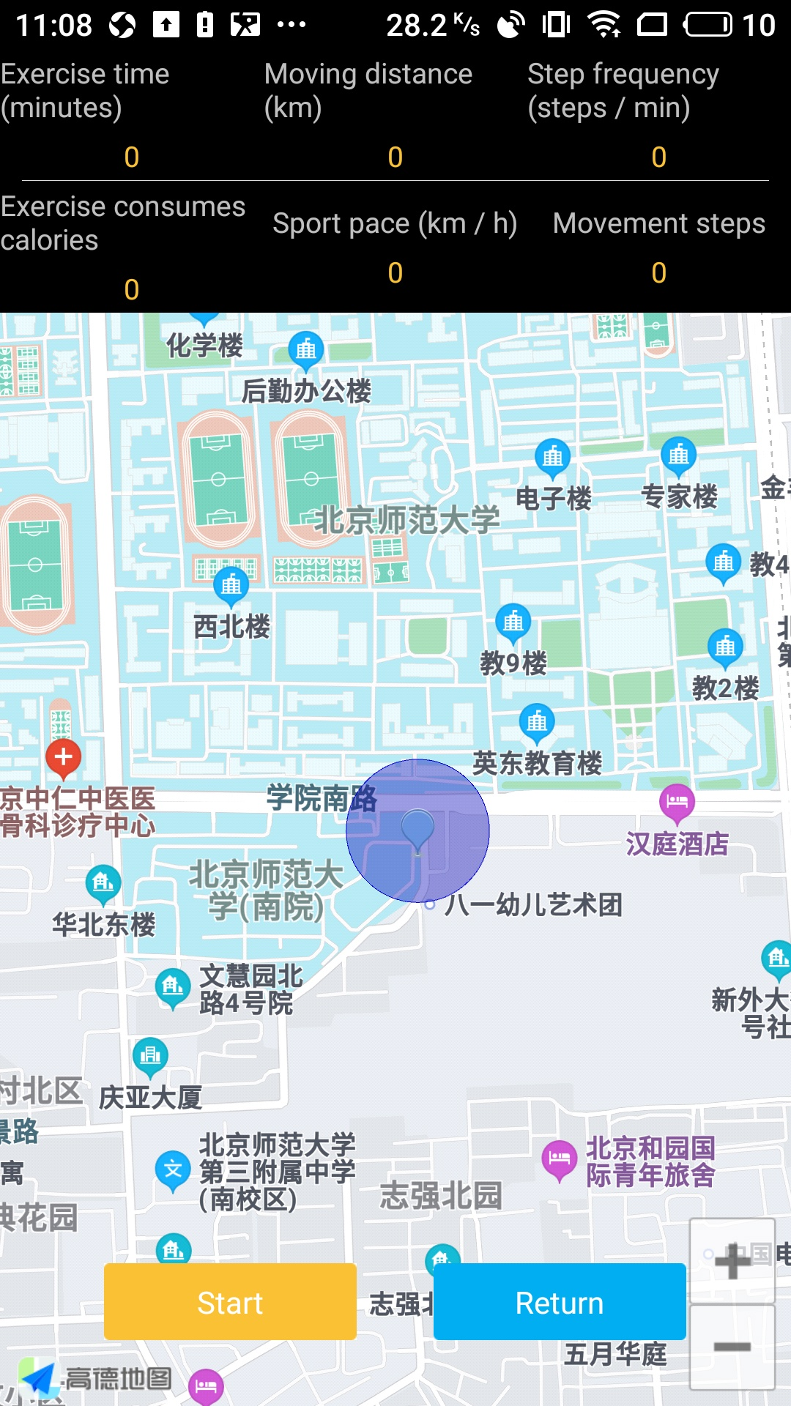

*Figure 14 Move interface*

* exit

Click "exit", users can log out of the current account.

## Setting

Click "Setting" to enter the setting interface as shown in Figure 15. "Setting" interface includes “Parameter setting”, “Privacy”, “Message notification”, “Cache management”, “Invite friends”、“Help and feedback” and “About us”.

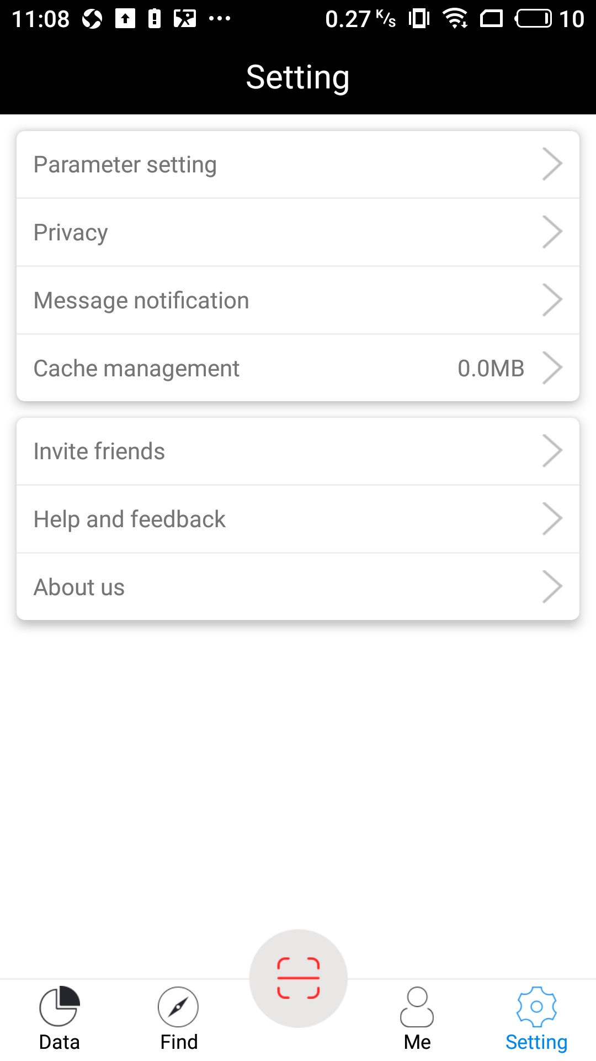

*Figure 15 Setting interface*

* Parameter setting

As shown in figure 16, users can modify “Compression quality”, “Sample”, “Leaf area projection ratio(G)”, “Data value score”, “Saturation”, “Blue band”, “Brightness value”, “Greenness index” and “Number of continuous measurements”.

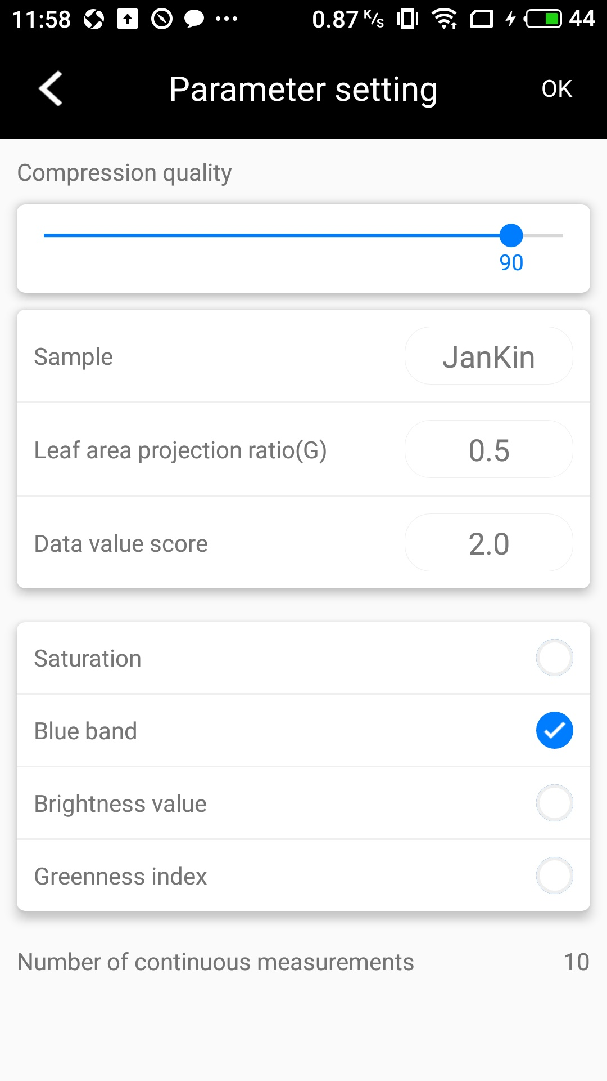

*Figure 16 Parameter Setting interface*

* Privacy

As shown in figure 17, users can set whether to "Recommend my contacts to me" and "In the neighborhood".

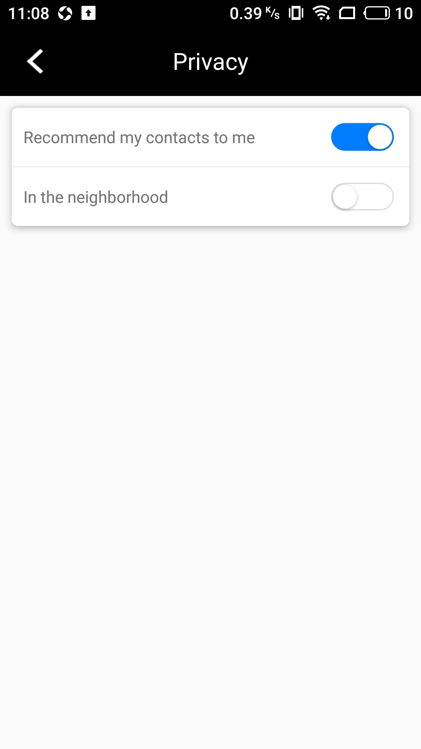

*Figure 17 Privacy interface*

* Message notification

As shown in figure 18, users can set "System notification reminder" .

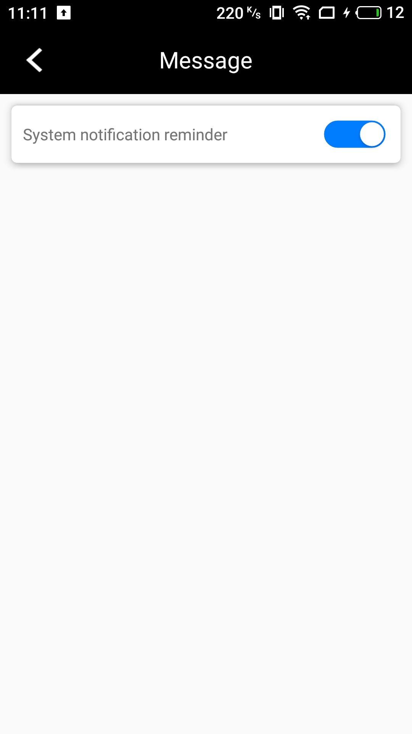

*Figure 18 Message Notification interface*

* Cache management

As shown in figure 19, when click Cache Management, the prompt box "cleared successfully" will pop up automatically.



*Figure 19 Cache Management interface*

* Invite friends

As shown in figure 20, users can invite " Wechat friends", " Wechat circle of friends", "QQ friends" and "QQ space".

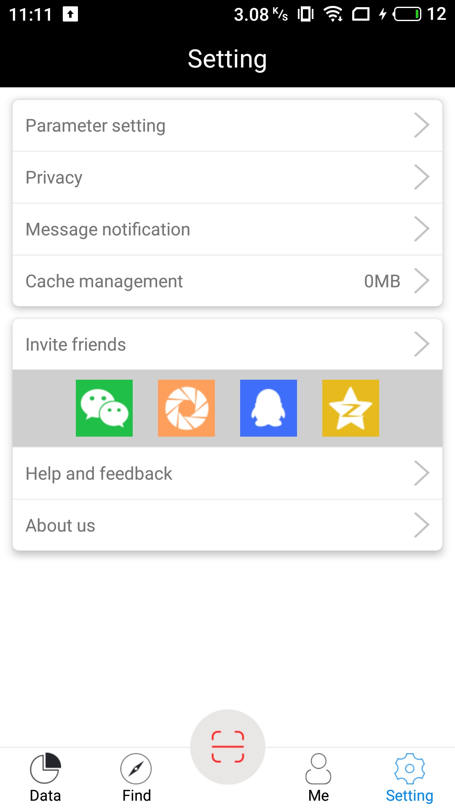

*Figure 20 Invite Friends interface*

* Help and feedback

As shown in figure 21, there is a user feedback question list.

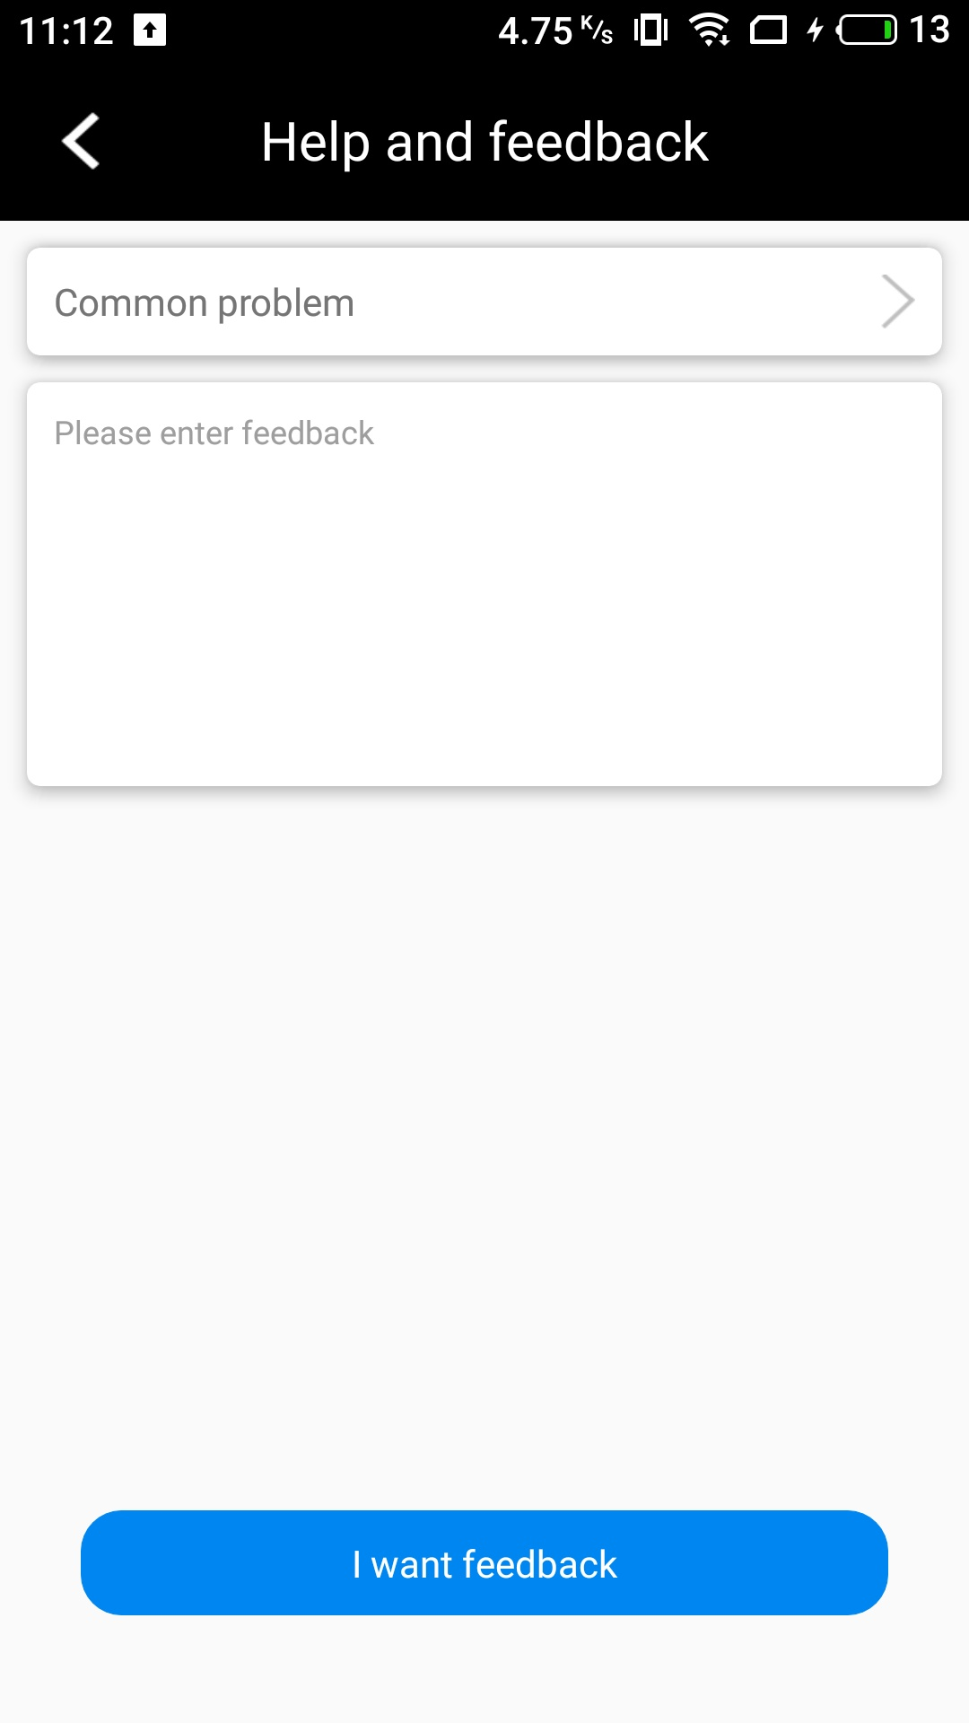

*Figure 21 Help and Feedback interface*

* About us

As shown in figure 22, users can view the “Version update”, Email and “Terms of service” of the application software.

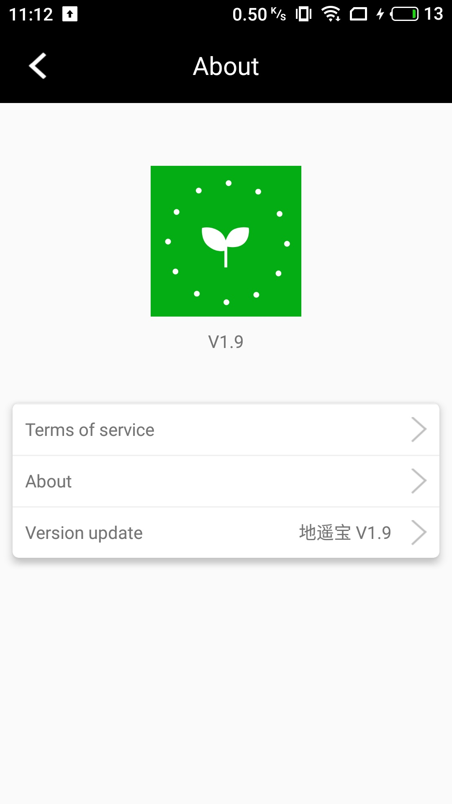

*Figure 22 About Us interface*

# Using LAISmart Step By Step

## Setting parameters

Before the measurement, first set the processing parameters in the application software “Parameter setting” interface as shown in figure 23.

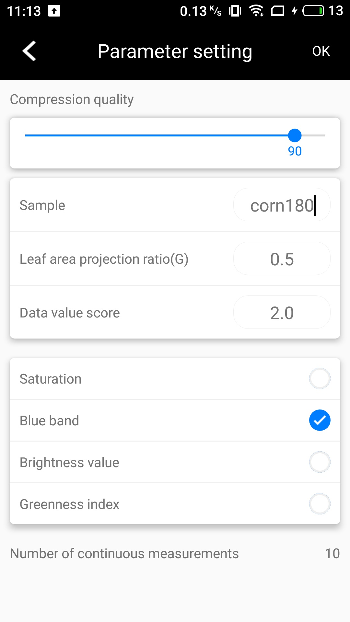

*Figure 23 Parameter Setting interface*

* Sample：Users can set the sample name according to the demand.
* Leaf area projection ratio(G)：G value in Beer Law. In most case, it is set as 0.5.
* Data value score: Generally, the default value is 2.0.
* Parameters for the classifying of plant image：Options include “Saturation”, “Blue band”, “Brightness value” and “Greenness index”. In most case, we use the blue band or greenness index for diffusive light environment. Blue band for high tree and using front camera, greenness index for low plant and using back camera.

After setting the above basic parameters, click "OK" in the upper right corner to save the settings.

## Measuring LAI

When completing the parameter settings, return to the home interface of the application software. Click the button  to enter the measuring interface as shown in figure 24. You can measure LAI in any light environment, but it is generally recommended to measure in diffusive light environment, such as dawn and sunset time or cloudy weather.

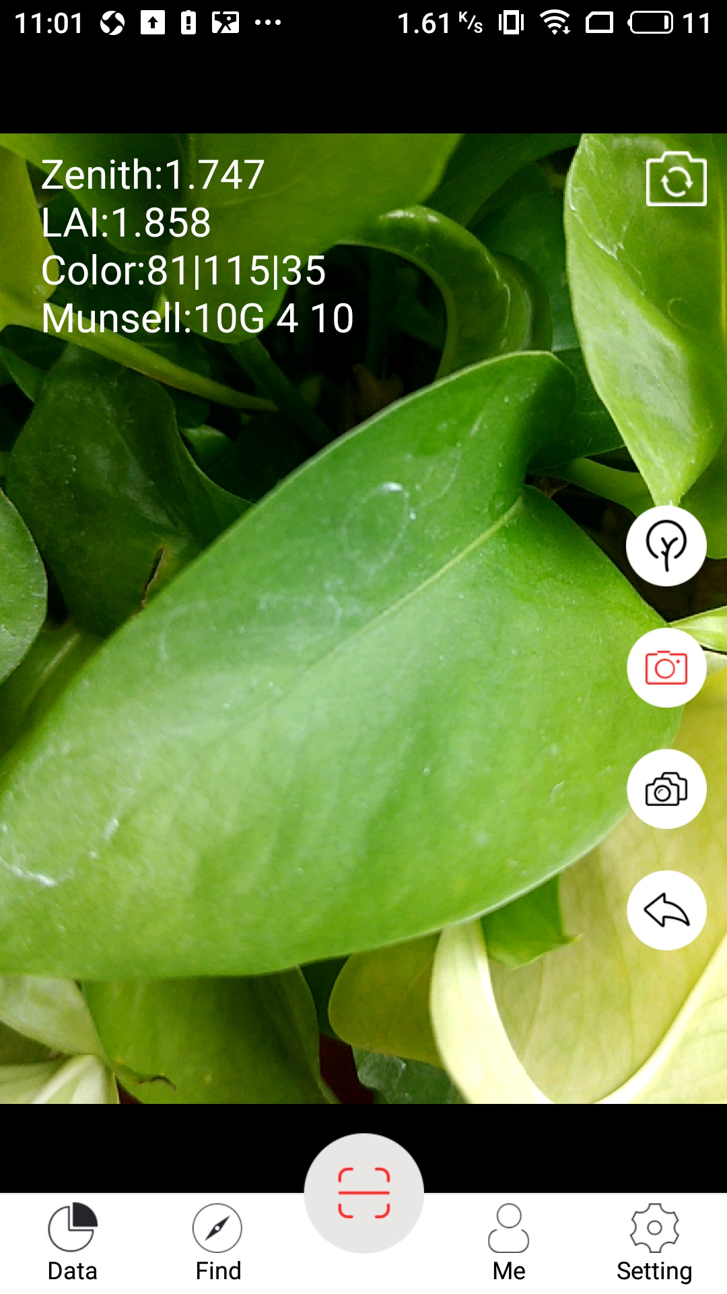

*Figure 24 Measuring interface*

* Upper right corner conversion button: This button can realize the conversion of front and back cameras. Generally, it is recommended to select the front camera when shooting high tree upward and the back camera when shooting low plant downward.
* Information details in the upper left corner: the camera zenith, LAI, Color(the averaged RGB values of image) and the Munsell color value(the color information is not directly used to LAI yet. So please ignore it) are displayed here. Please keep the phone in level mode, i.e., the zenith angle near to zero.
* Other buttons：See section 3.2 for details.

Click any place of the screen you will hear the tone “DING”, then one measurement is finished. When moving along the transection, and keep clicking the screen in several steps interval, you will get many LAI values of the transection. In most case, you may want to calculate the mean LAI value of the transection, then you can view the individual LAI value in the viewing data mode.

## Viewing data

In the measuring mode, the LAI valued displayed on the upper left corner in real time mode. When measurement finished, click “Data” button, then the measured data and the images are displayed in the data interface as shown in figure 25.



*Figure 25 Data interface*